Title: Support Ticket Structured Data Extraction using LLM

1. Introduction
In modern customer support systems, users submit issues in free-form text, which is unstructured and difficult to process automatically. This project focuses on converting such unstructured support tickets into structured JSON data using a Large Language Model (LLM).
The system extracts key fields such as issue category, urgency, sentiment, and a concise summary. It ensures consistent output using prompt engineering and validation techniques, making the data suitable for automation and analysis.

Problem Statement
Customer support tickets are:
- Unstructured and inconsistent
- Difficult to categorize automatically
- Hard to prioritize based on urgency
- Time-consuming to process manually

3. Proposed Solution
This project uses an LLM to extract structured information from support tickets and return it in a fixed JSON format.

Extracted Fields:
- issue_category
- urgency (low / medium / high)
- sentiment (positive / negative / neutral)
- one_sentence_summary
The system ensures:
- Always valid JSON output
- No missing fields
- Consistent classification

4. System Architecture
- Input: Raw support ticket (text)
- LLM Processing: Prompt-engineered model extracts structured data
- Validation Layer: Checks for missing/invalid fields
- Fallback System: Handles API failures using rule-based logic
- Output: Clean JSON object

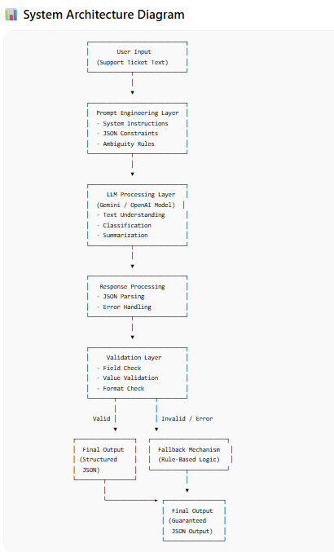

5. Methodology

5.1 Prompt Engineering
A strict system prompt is designed to:
- Enforce JSON-only output
- Restrict values (urgency, sentiment)
- Handle ambiguity using rules

5.2 Deterministic Output
- Temperature is set to 0
- Ensures consistent results for same input

5.3 Validation
- Checks all required fields
- Verifies allowed values
- Prints warnings if issues found

5.4 Fallback Mechanism
If API fails:
- Uses rule-based extraction
- Ensures system never breaks

6. Test Cases

Normal Cases (5 Tickets)
- Network issue (high urgency)
- Login issue (medium urgency)
- Billing issue (positive sentiment)
- App crash (negative sentiment)
- Performance issue (low urgency)

Confusing Case
Example:
“It’s not urgent, but it’s frustrating and sometimes not working.”
Challenges:
- Mixed sentiment
- Unclear urgency

7. Challenges Faced
- API errors (401, 429, 404)
- Model deprecation issues
- Handling ambiguous inputs
- Ensuring strict JSON output

8. Improvements
To handle confusion:
- Default urgency → medium
- Choose dominant sentiment
- Added stricter prompt rules

9. Results
- Successfully generated structured JSON output
- Validation ensured correctness
- Fallback handled API failures
- System worked for both normal and ambiguous inputs

10. Applications
- Customer support automation
- Ticket prioritization systems
- Sentiment analysis dashboards
- CRM tools

11. Conclusion
This project demonstrates how LLMs can be effectively used to convert unstructured customer data into structured, machine-readable formats. By combining prompt engineering, validation, and fallback mechanisms, the system achieves reliability and consistency.
Handling ambiguous cases highlights the importance of well-defined rules in prompt design. Overall, the project showcases a practical approach to building robust, production-ready AI pipelines.

12. Future Enhancements
- Use advanced classification models
- Add multi-language support
- Improve fallback with ML models
- Deploy as API or web app

13. Technologies Used
- Python
- LLM (OpenAI / Google Gemini)
- JSON
- Prompt Engineering

